• Sketch the "as-is" and "to-be" models of a software system you know well.

Shopee does not have an image search function. This would be a good function to add because it would make searches more specific.

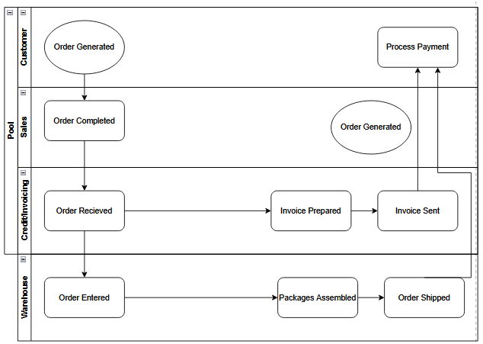

• What is the main driver for the change you introduced?

Optimization, Organization, Technology

• What was the impact of your change on the architecture?

The impact of our change is that searches will be more precise for customers, and will hopefully cut down on repeated search queries.

• Which types of changes are easy or hard to apply to the original architecture?

Easiest is Extensibility. This is because Hardest is Customizability and Elasticity. This is because it uses machine learning which uses more resources.

• How can you change your architecture to make it easier to evolve with respect to similar changes in the future?